Polar Small Circle
# Source: AI Source: Provided by: [Data Path: Persons Table -> ID Column: 1, Name_En Column: Motasem Essam] -> From: [ChatGPT] on [7/25/2026]
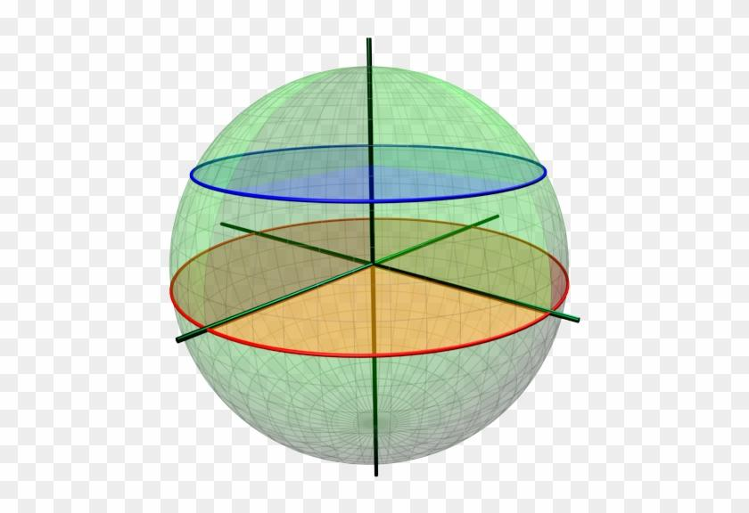
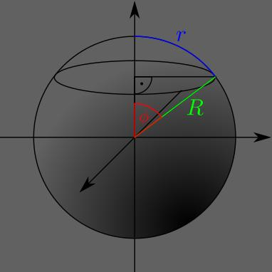
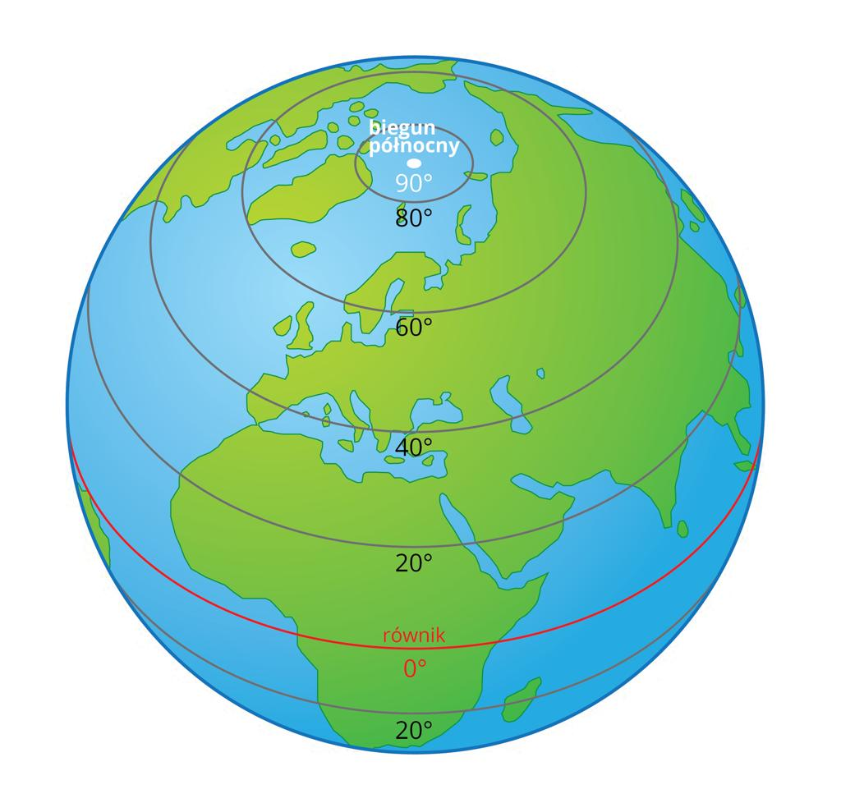

Definition
# Source: AI Source: Provided by: [Data Path: Persons Table -> ID Column: 1, Name_En Column: Motasem Essam] -> From: [ChatGPT] on [7/25/2026]
A polar small circle is a small circle on a sphere located near one of its poles, typically formed by intersecting the sphere with a plane parallel to the equatorial plane and close to the pole.
On Earth, a circle of latitude at a high northern or southern latitude is an example. For instance, the Arctic Circle and Antarctic Circle are polar-region circles of latitude.
Important distinction: “Polar small circle” is a descriptive term based on location near a pole, rather than a universally standardized mathematical category. Geometrically, it is a small circle like any other circle formed by a plane that does not pass through the sphere’s center.

Simple Definition
# Source: AI Source: Provided by: [Data Path: Persons Table -> ID Column: 1, Name_En Column: Motasem Essam] -> From: [ChatGPT] on [7/25/2026]
A polar small circle is a small circular line around a sphere near its North Pole or South Pole. It is parallel to the equator but much smaller than the equatorial great circle when it is close to a pole.

Geometric Structure
# Source: AI Source: Provided by: [Data Path: Persons Table -> ID Column: 1, Name_En Column: Motasem Essam] -> From: [ChatGPT] on [7/25/2026]
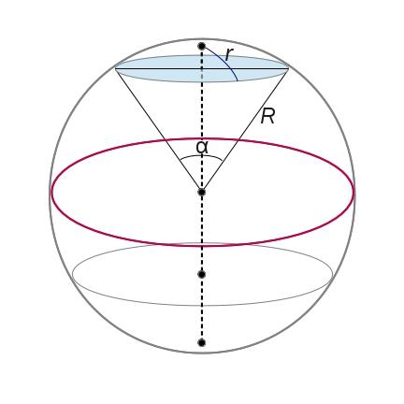
The main geometric elements are:
- Sphere center $O$: The center of the sphere.
- North Pole or South Pole: The selected pole near which the small circle is located.
- Polar small-circle plane: A plane parallel to the equatorial plane that intersects the sphere near the selected pole.
- Small-circle center $C$: The point where the sphere’s polar axis intersects the small-circle plane.
- Sphere radius $R$: The distance from the sphere’s center to its surface.
- Small-circle radius $r$: The distance from $C$ to the circle.
- Latitude $φ$: The latitude measured from the equator.
- Colatitude $α$: The angular distance from the selected pole to the small circle, measured along a meridian.
For a northern polar small circle, latitude is close to ${90}^{∘}\text{ N}$. For a southern polar small circle, it is close to ${90}^{∘}\text{ S}$.

Mathematical Representation
# Source: AI Source: Provided by: [Data Path: Persons Table -> ID Column: 1, Name_En Column: Motasem Essam] -> From: [ChatGPT] on [7/25/2026]
Consider a sphere centered at the origin with radius $R$, with its polar axis along the $z$-axis.
The sphere equation is
$$x^{2}+y^{2}+z^{2}=R^{2}$$
For a northern small circle at latitude $φ$, the plane is
$$z=R\sin{φ}$$
The circle’s equation becomes
$$x^{2}+y^{2}=R^{2}\cos^{2}{φ}$$
Therefore,
$$\boxed{r=R\cos{φ}}$$
Alternatively, using the colatitude $α$, measured from the North Pole or South Pole toward the circle,
$$α={90}^{∘}-\left|φ\right|$$
Thus,
$$\boxed{r=R\sin{α}}$$
These formulas describe the same circle using two different angular measurements.

Important Formulas
# Source: AI Source: Provided by: [Data Path: Persons Table -> ID Column: 1, Name_En Column: Motasem Essam] -> From: [ChatGPT] on [7/25/2026]
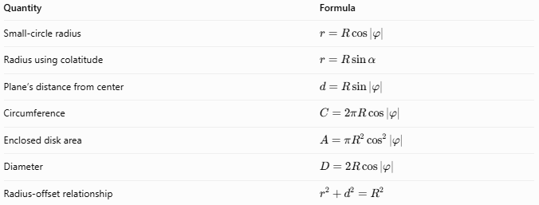
Quantity | Formula
Small-circle radius | $$r=R\cos\left|φ\right|$$
Radius using colatitude | $$r=R\sin{α}$$
Plane’s distance from center | $$d=R\sin\left|φ\right|$$
Circumference | $$C=2πR\cos\left|φ\right|$$
Enclosed disk area | $$A=πR^{2}\cos^{2}\left|φ\right|$$
Diameter | $$D=2R\cos\left|φ\right|$$
Radius-offset relationship | $$r^{2}+d^{2}=R^{2}$$
Here, $R$ is the sphere radius, $φ$ is the latitude, and $α$ is the colatitude.

Worked Example
# Source: AI Source: Provided by: [Data Path: Persons Table -> ID Column: 1, Name_En Column: Motasem Essam] -> From: [ChatGPT] on [7/25/2026]
A spherical model has a radius of $10\text{ cm}$. A polar small circle lies at latitude ${80}^{∘}\text{ N}$. Find its radius and circumference.
Step 1 — Calculate the circle radius.
$$r=R\cos{φ}$$
$$r=10{\cos{80}}^{∘}$$
$$\boxed{r≈1.736\text{ cm}}$$
Step 2 — Calculate the circumference.
$$C=2πr$$
$$C=2π\left(1.736\right)$$
$$\boxed{C≈10.91\text{ cm}}$$
Step 3 — Calculate the colatitude.
$$α={90}^{∘}-{80}^{∘}$$
$$\boxed{α={10}^{∘}}$$
Conclusion: The polar small circle has a radius of approximately $1.736\text{ cm}$ and a circumference of approximately $10.91\text{ cm}$. Its small size results from its proximity to the pole.

Comparison with Related Circles
# Source: AI Source: Provided by: [Data Path: Persons Table -> ID Column: 1, Name_En Column: Motasem Essam] -> From: [ChatGPT] on [7/25/2026]
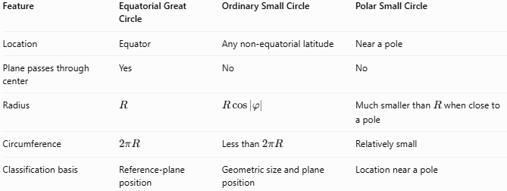
Feature | Equatorial Great Circle | Ordinary Small Circle | Polar Small Circle
Location | Equator | Any non-equatorial latitude | Near a pole
Plane passes through center | Yes | No | No
Radius | $$R$$ | $$R\cos\left|φ\right|$$ | Much smaller than $R$ when close to a pole
Circumference | $$2πR$$ | Less than $2πR$ | Relatively small
Classification basis | Reference-plane position | Geometric size and plane position | Location near a pole
A polar small circle is not fundamentally different from other small circles. The distinction is that its latitude is close to either pole.

Examples and Applications
# Source: AI Source: Provided by: [Data Path: Persons Table -> ID Column: 1, Name_En Column: Motasem Essam] -> From: [ChatGPT] on [7/25/2026]
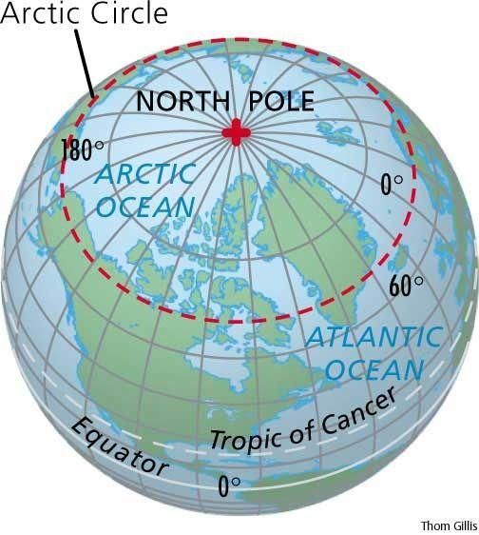
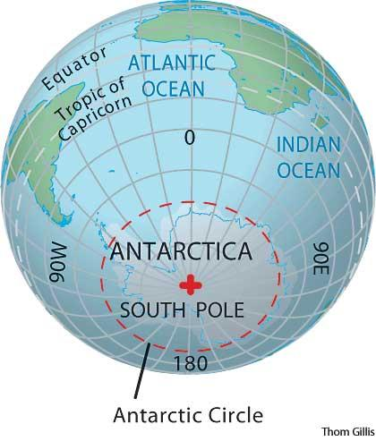
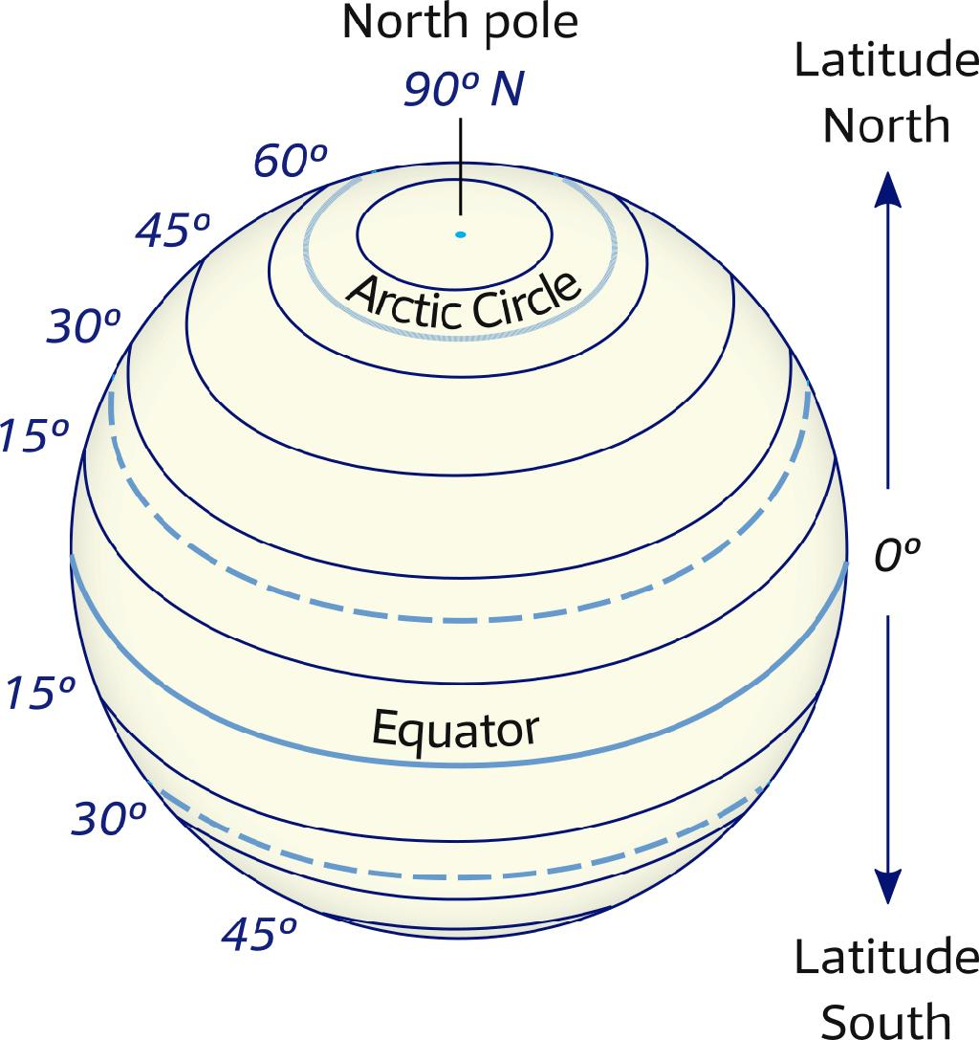
Examples include:
- Arctic Circle: Approximately ${66.56}^{∘}\text{ N}$, a high-latitude small circle.
- Antarctic Circle: Approximately ${66.56}^{∘}\text{ S}$, a high-latitude small circle.
- Higher-latitude circles: Circles closer to either pole, such as ${80}^{∘}\text{ N}$ or ${80}^{∘}\text{ S}$.
Applications include:
- Representing high-latitude regions on globes and maps.
- Studying polar geography and climate zones.
- Calculating circumferences and distances along high-latitude parallels.
- Modeling spherical cross-sections near the poles.
- Understanding latitude, colatitude, and spherical coordinates.

Key Points
# Source: AI Source: Provided by: [Data Path: Persons Table -> ID Column: 1, Name_En Column: Motasem Essam] -> From: [ChatGPT] on [7/25/2026]
- A polar small circle lies near the North Pole or South Pole.
- Its plane is parallel to the equatorial plane but does not pass through the sphere’s center.
- It is a location-based subset of northern or southern small circles.
- Its radius is $r=R\cos\left|φ\right|$.
- As the circle approaches a pole, its radius and circumference approach zero.
- At the exact pole, the limiting circle becomes a single point, not a proper circle.
- The term polar small circle is descriptive; the underlying geometric object is an ordinary small circle.

Conclusion
# Source: AI Source: Provided by: [Data Path: Persons Table -> ID Column: 1, Name_En Column: Motasem Essam] -> From: [ChatGPT] on [7/25/2026]
A polar small circle is a small circle on a sphere positioned near either pole. Its radius and circumference decrease as its latitude approaches ${90}^{∘}$ north or south. Although the term emphasizes its polar location, it follows the same mathematical principles as every other small circle.

